Figure 1. Trend lines of Government Response Index and Death Rate in 2020 and 2021 at Hubei (Province of Wuhan) China.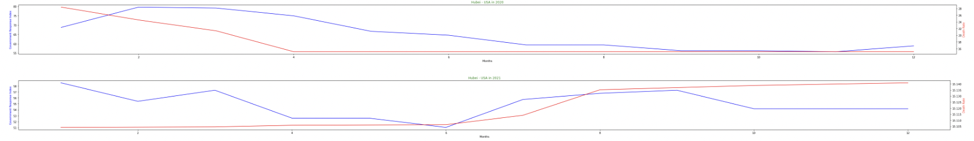

Figure 2. New York in 20-21 Figure 3. Ohio 20 - 21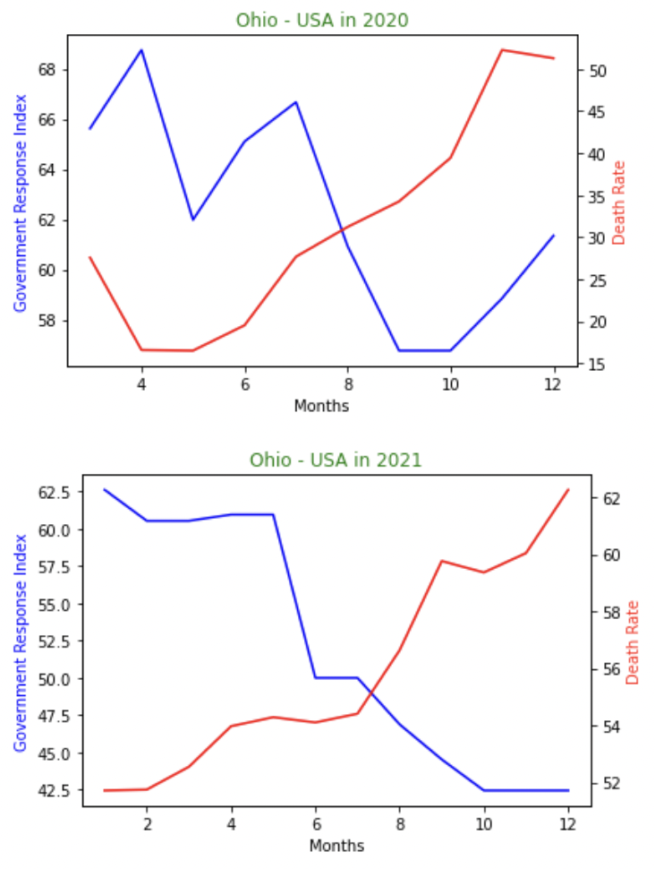

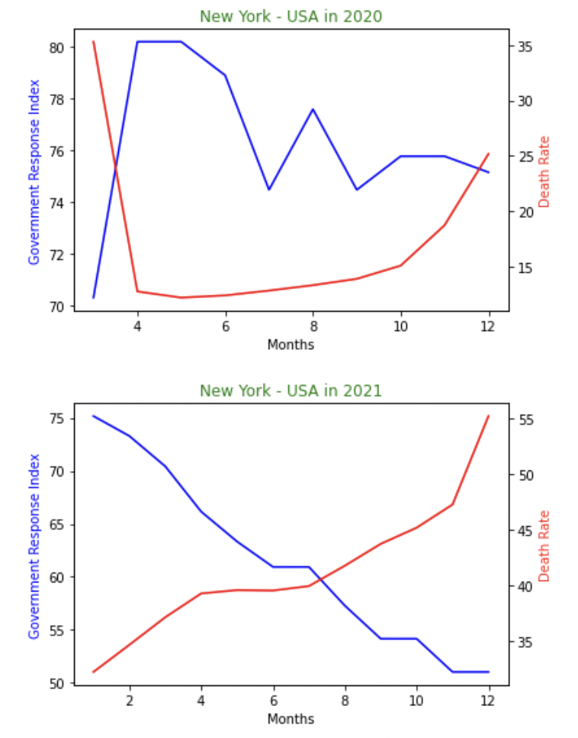

Figure 4. Records of overall (mean) Government Response Index worldwide

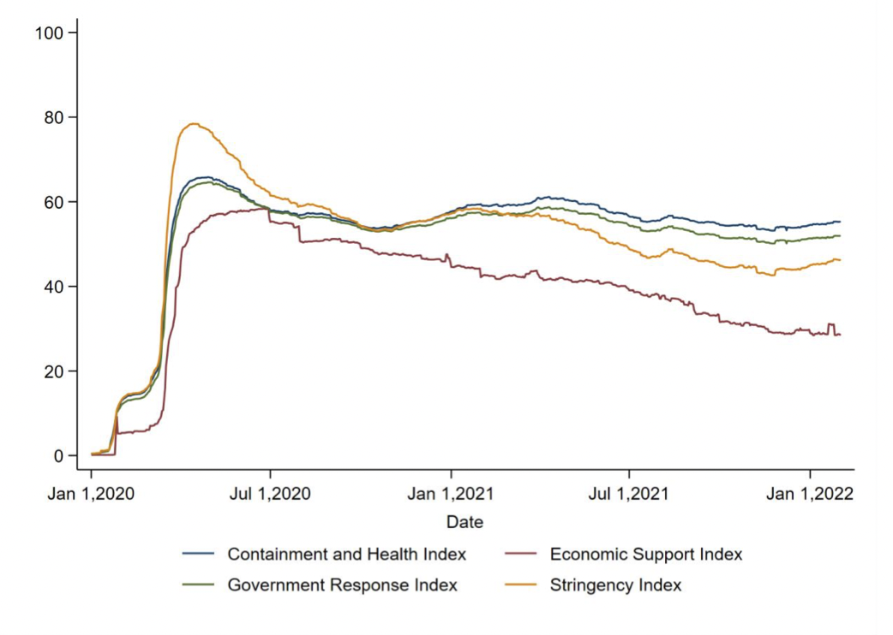

Intro:

SARS-CoV-2, the virus that causes COVID-19, was initially detected in December of 2019 in Wuhan, China (CDC, 2021). SARS-CoV-2 attacks the respiratory system of its host, causing symptoms such as fever, coughing, breathlessness, and sore throat, and others (CDC, 2022). Droplets containing the virus can be suspended in the air or rest on surfaces as a result of speaking, coughing, or breathing (CDC, 2021), infecting other people and spreading the infection further. Because COVID-19 is highly infectious, governments all around the world have taken precautions to keep it from spreading. The government's reaction to COVID-19 differs greatly throughout the world. 2022) (Wade).

Governments imposed measures to limit people's interaction with others in the aim of halting COVID-19's spread (CDC, 2022). Lockdowns, quarantines, and limited social gatherings are a several of the limitations. Some emergency vaccines were eventually produced in order to discourage the virus from spreading further; however, its immunological impact, safety, efficiency, and duration of action are all unclear at this time (CDC, 2021).

Based on the severity of the limitations, the number of COVID-19 cases, and the number of deaths caused by COVID-19 from the records of University of Cambridge (United Kingdom), this study evaluates the effectiveness of these restrictions which made by the Government around the world (such as quarantine rules, lockdown restraints, and so on).

Abstract:

